File Name: animalShelter.py

Programmer: Unique Chambers

Date: April 8, 2024

Version: 2.0

Description: This code is a simple Python class AnimalShelter designed to interact with a MongoDB database using Pymongo.

—------------------------------------------------------------------------------------------------------------------

Narrative:

For my CS 340 Client/Server Development assignment, I enhanced an existing Python class, AnimalShelter, focusing on implementing CRUD (Create, Read, Update, Delete) functionality for a MongoDB document collection using the PyMongo driver. This decision was motivated by a desire to deepen my understanding of database interactions in client/server applications, a crucial aspect of modern software development.

The original code provided a foundation for essential create and read operations, offering a starting point for MongoDB database interaction. Recognizing the significance of these operations in real-world applications, I saw an opportunity to fulfill the assignment requirements and explore the foundational principles of database-driven applications.

Enhancing the CS 340 assignment code allowed me to delve into the core functionality of database-driven applications. The goal was clear: implement CRUD operations for a MongoDB document collection utilizing the PyMongo driver. Through this process, I aimed to showcase several skills crucial for server-side development and effective database interactions.

The initial step involved understanding the client/server architecture. This required setting up a MongoDB database and crafting Python code for server-side logic. This process enhanced my comprehension of how client applications interact with and manipulate data on the server. To ensure data integrity and security, I implemented data validation checks. This included validating that the inserted data met specific criteria, such as not being empty or null. Additionally, I incorporated robust error handling to manage unexpected scenarios gracefully, providing informative feedback to users if an operation failed.

Maintainability is paramount for long-term development. I improved the code's readability and maintainability by adding comments, using clear method names, and following best practices. These efforts align with industry standards and facilitate collaboration with other developers.

Enhancing the code for the CS 340 assignment involved employing strategies to cultivate a collaborative environment supportive of diverse audiences within the field of computer science. Here's how the enhancement aligns with specific course outcomes:

***Building Collaborative Environments:***

Understanding Client/Server Architecture: This endeavor delved into the fundamentals of client/server architecture, a core concept in computer science. This understanding is vital for collaboration among diverse teams, forming the backbone of modern web applications. Implementing CRUD Operations: Implementing CRUD operations necessitated thoughtful consideration of various design choices, including data structures and algorithms. This collaborative effort between developers and database administrators ensures solutions that are efficient, scalable, and aligned with diverse stakeholder needs.

***Professional-Quality Communications:***

Documentation and Comments: I enhanced the code with detailed comments and documentation, which is crucial for collaborating with diverse audiences. Clear documentation assists other team members in understanding the codebase, its functionalities, and how to interact with it. Coherent and Technical Writing: The documentation and comments were crafted coherently and technically, tailored to the specific audience of fellow developers. This ensures that the codebase remains understandable and maintainable by others.

***Computing Solutions and Algorithmic Principles:***

Designing Efficient Solutions: The development of CRUD operations necessitated careful consideration of algorithmic principles and data structures. These decisions impact the system's efficiency and scalability. Collaboratively evaluating these choices ensures that the best solutions are implemented. Trade-offs in Design Choices: Managing trade-offs was integral to the enhancement process. Collaboratively discussing and evaluating these trade-offs allows diverse teams to make informed decisions that balance performance, scalability, and maintainability.

***Industry-Specific Computing Practices:***

Using PyMongo Library: Leveraging the PyMongo library for MongoDB interactions reflects industry-specific practices. This library is widely used in the industry for working with MongoDB databases. Collaboratively utilizing industry-standard tools ensures alignment with best practices. Database Optimization: Implementing bulk insertions for efficiency demonstrates an understanding of industry-specific goals. Collaboratively optimizing database operations ensures that the system delivers value in terms of performance and scalability.

***Developing a Security Mindset:***

Anticipating Adversarial Exploits: Enhancing the code involved considering security implications. This includes anticipating adversarial exploits and implementing data validation to prevent vulnerabilities. Collaboratively discussing and implementing security measures ensures the system is resilient to potential threats. Privacy and Data Security: The enhancement process also focused on ensuring privacy and enhanced data security. Collaboratively designing these aspects into the system protects sensitive information and aligns with industry standards for data protection.

In conclusion, the enhancements to the AnimalShelter.py code for the CS 340 assignment fulfilled the assignment requirements and provided a comprehensive exploration of database-driven applications. By carefully considering architecture, efficient solutions, clear communication, and security measures, I aimed to showcase essential skills in server-side development and database interactions. These enhancements align with course outcomes and industry standards, contributing to a robust understanding of modern software development practices.

Create:

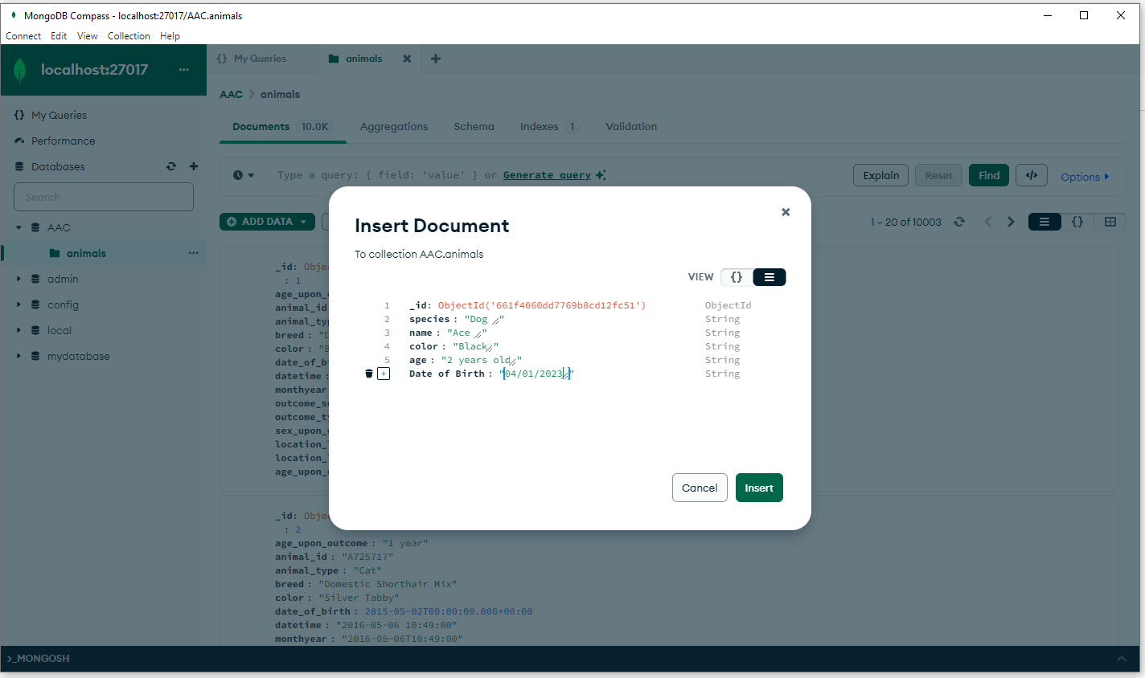

Read

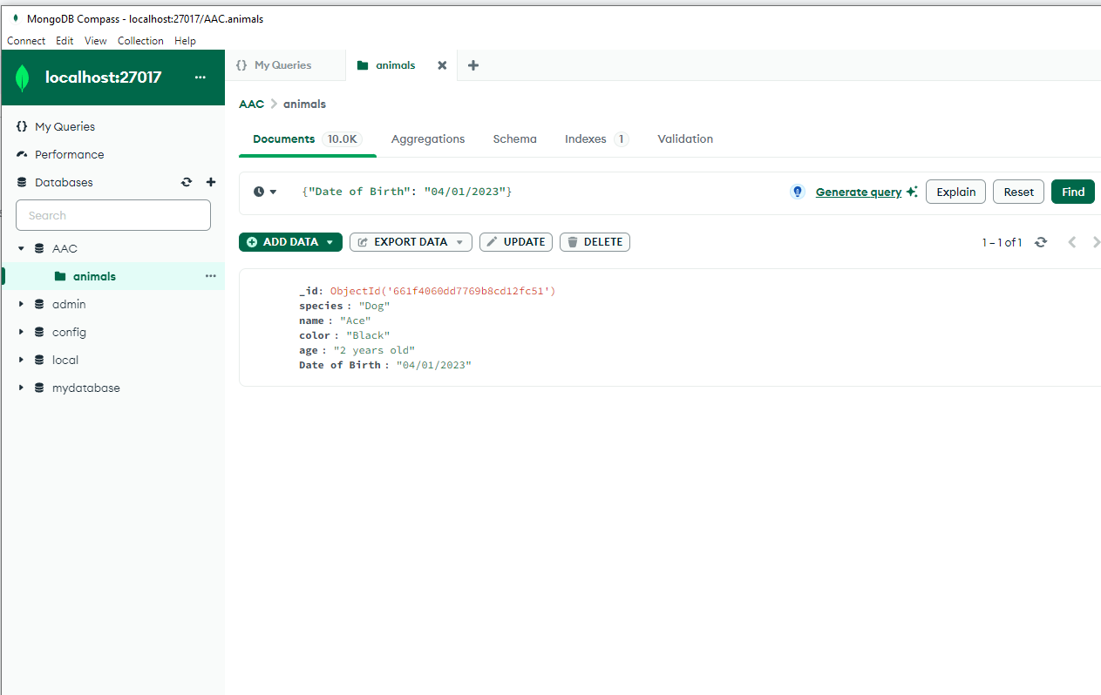

Update

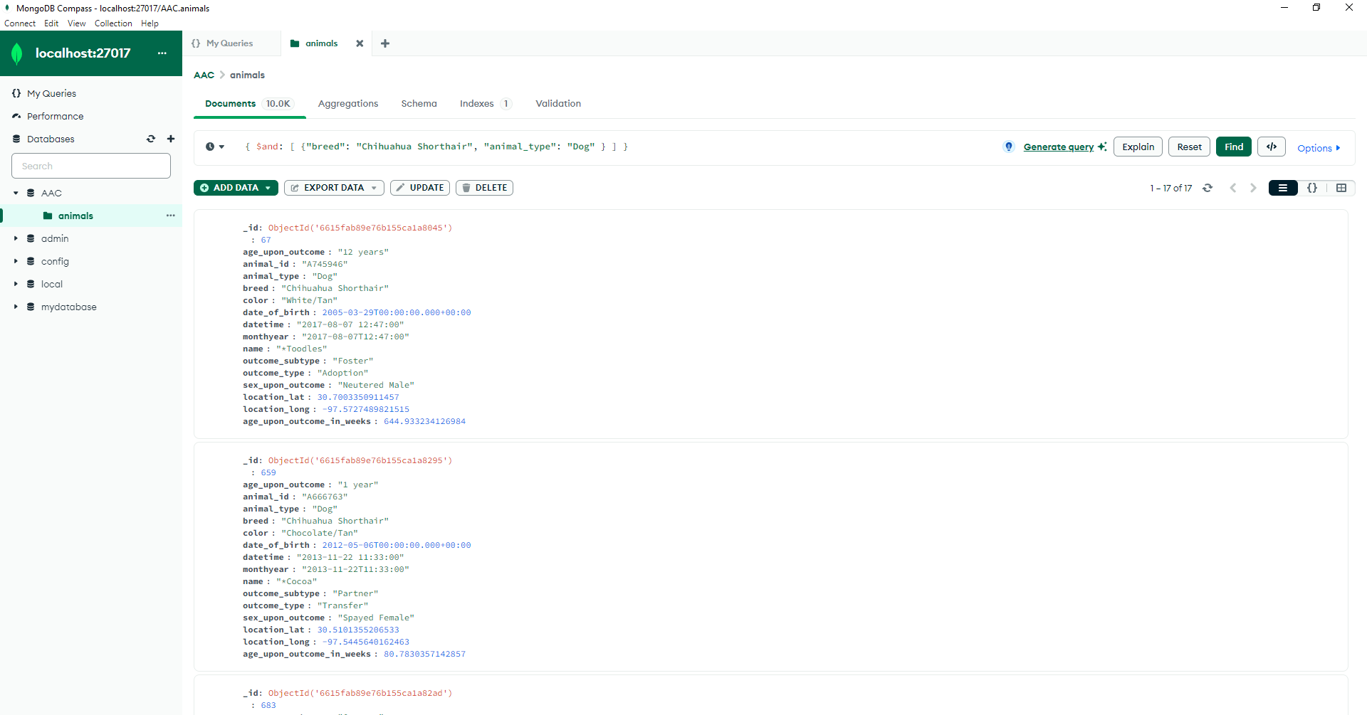

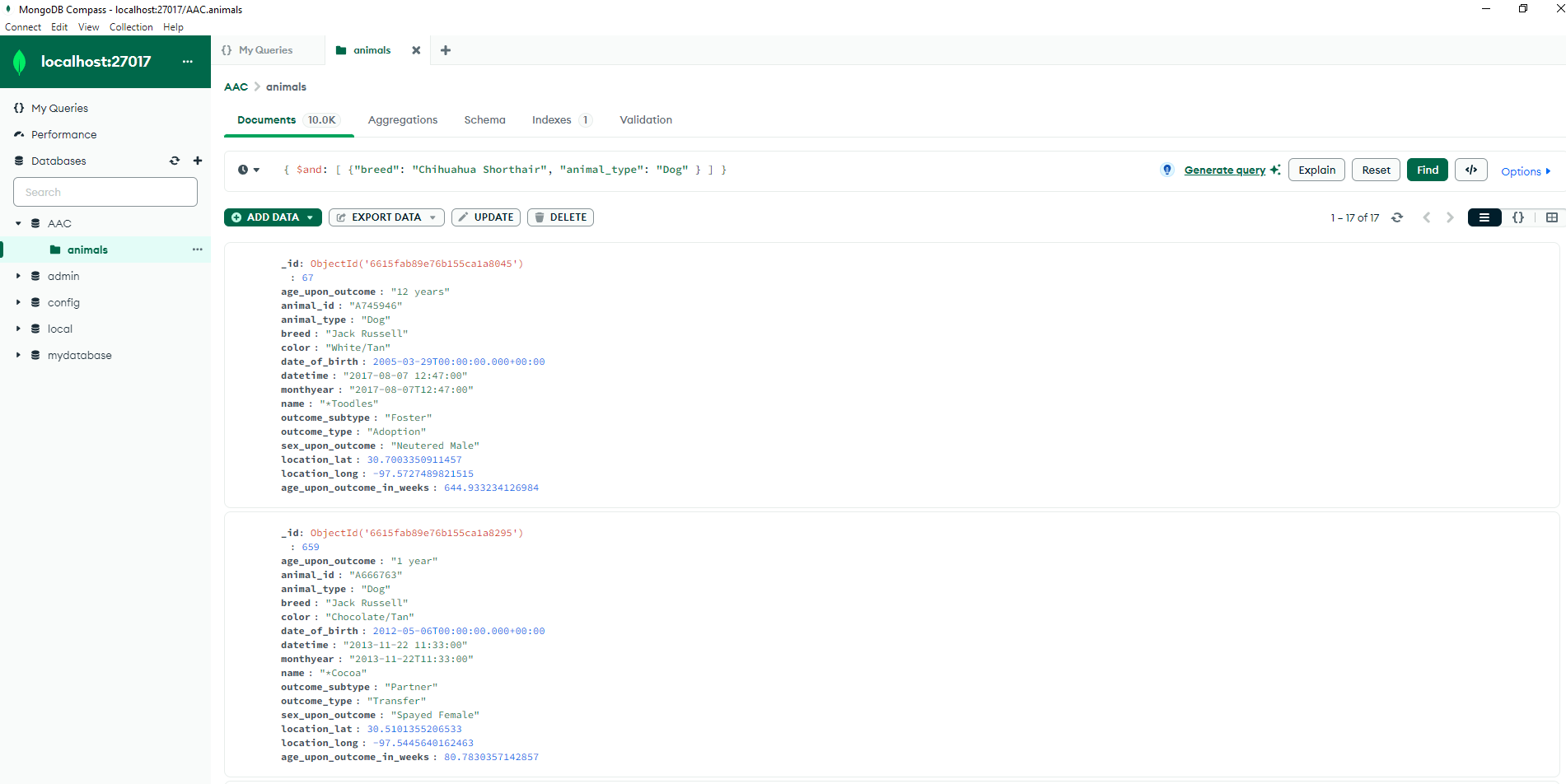

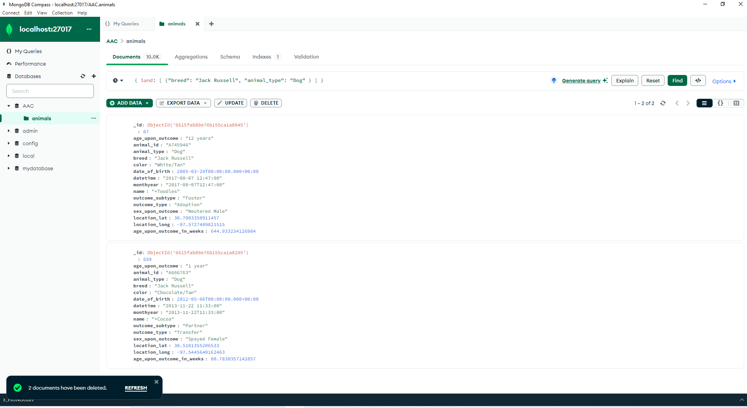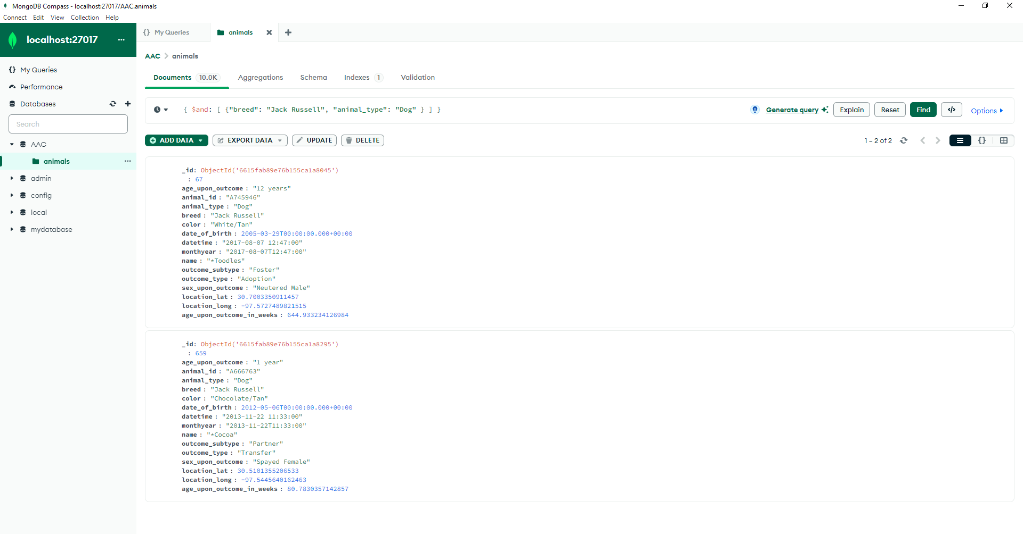

Delete

